ESPAC

Report 4792/R

On

Flazasulfuron

Small scale collaborative trial
for
the determination of Flazasulfuron A.I. and formulations
by HPLC

Report to CIPAC
On behalf of
ESPAC

June 2011

Contents Page

1. Participants 3

2. Active ingredient, general information 4

3. Samples 5

4. Method 5

4.1 Scope 5

4.2 Principle 5

4.3 Procedure 5

5. Comments from participants 6

6. Evaluation and discussion 7

6.1 Screening for valid data 7

6.2 Determination of Flazasulfuron content 7

Tables 1 – 3 8 - 9
Figs 1 5 - 6
Fig’s 2 – 6 10 - 13

7. Conclusion 13

1. Participants

Vanessa Lecocq, Christine Collart | Centre wallon de Recherches agronomiques (CRA-W)  Walloon Agricultural Research Centre  Pesticides Research Department  Rue du Bordia, 11  B-5030 GEMBLOUX  BELGIUM
Joe Moreland | Dow AgroSciences Crop Protection R&D  B.P. 20  8, route de Herrlisheim  67410 Drusenheim  France
Andrew Plumb | FERA  Sand Hutton  York  North Yorkshire  YO41 1LZ  England
Teddy Krongaard | National Environmental Research Institute,  University of Aarhus,  Department of Atmospheric Environment  Frederiksborgvej 399, PO Box 358  DK-4000 Roskilde,  Denmark
Jim Garvey | Pesticide Control Laboratory  Backweston Laboratory Campus  Backweston  Youngs Cross  Celbridge  Co. Kildare  Ireland

Participants are listed in alphabetical order whereas laboratory numbers are assigned on the basis of the order in which results were submitted.

2. Active ingredient, general information

Chemical name
2-pyridinesulfonamide,N-[[(4,6-dimethoxy-2-pyridimidinyl)amino]carbonyl]-3-(trifluoromethyl)

ISO common name Flazasulfuron

CAS No. 104040-78-0

Structure

Molecular mass: 407.36

Molecular Formula: C₁₃H₁₂F₃N₅O₅S

3. Samples

Two technical materials and three samples of formulations were sent to the participants, these are listed below. Participants in the trial also received an analytical standard with a purity of 99.9%.

1. Technical material 1
2. Technical material 2
3. 25WG1
4. 25WG2
5. 25WG3

4. Method

4.1 Scope

Determination of the active ingredient content of Flazasulfuron in technical grade active ingredients and in formulations.

4.2 Principle

Flazasulfuron is determined by reversed phase high performance liquid chromatography using UV detection at 230 nm and external standard calibration.

4.3 Procedure

See attached method for details.

Fig 1a Flazasulfuron Technical material.

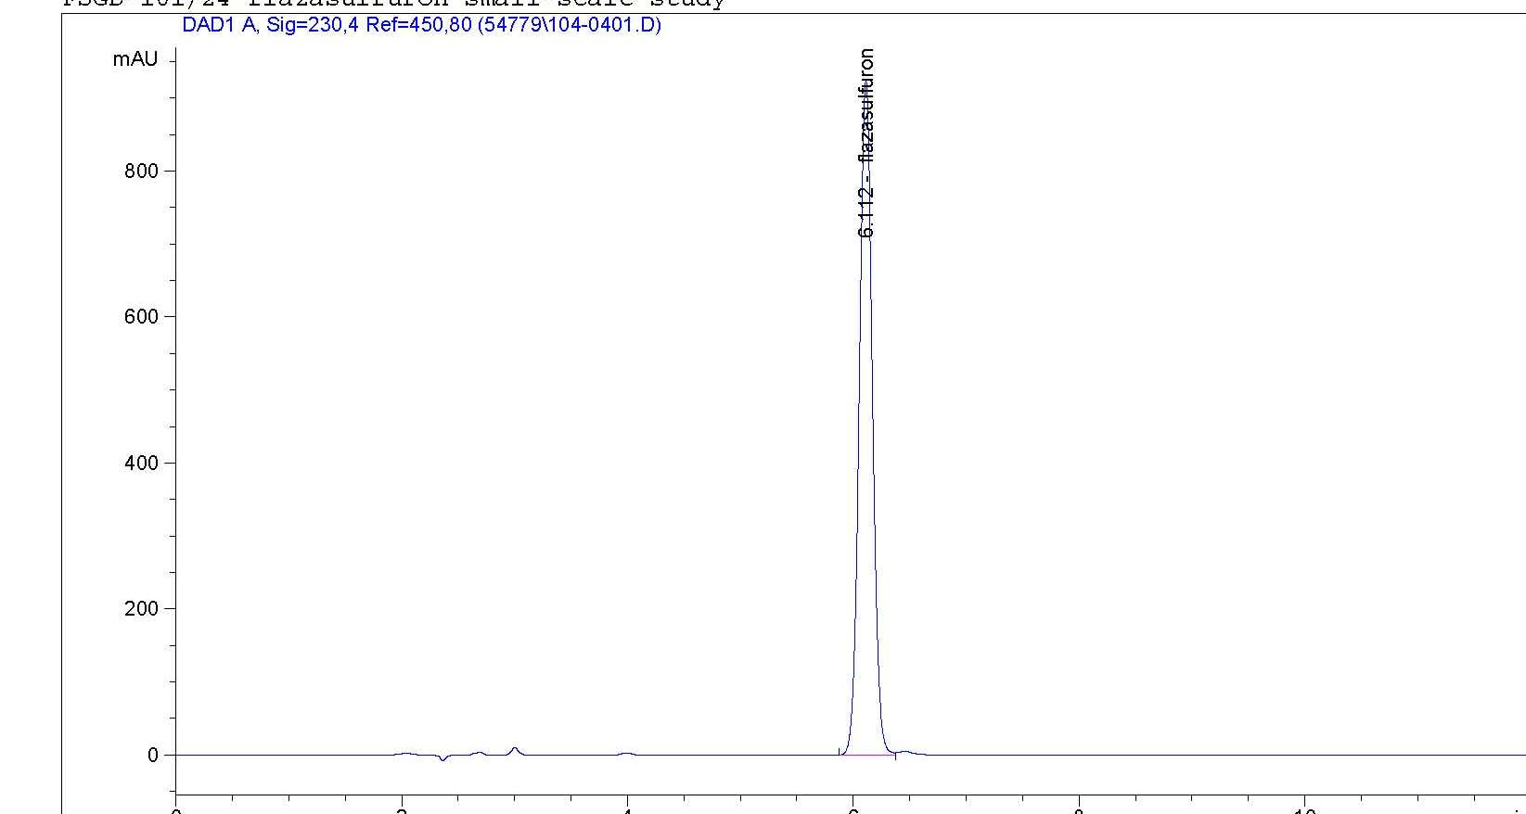

Fig 1 b Flazasulfuron WG 25

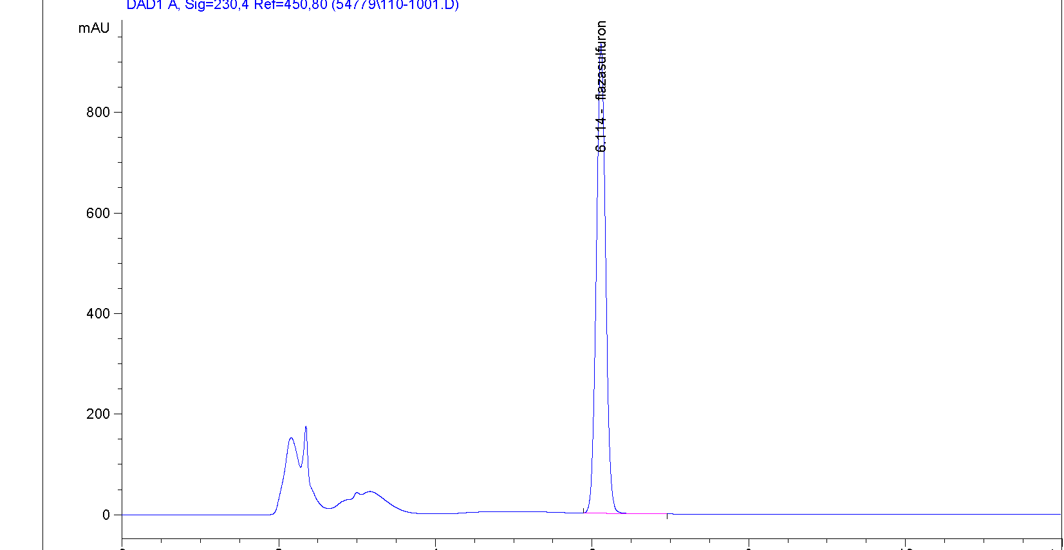

5. Comments from the Participants.

The following comments were received from the study participants.

Laboratory 1 Not full separation between a.i. and formulants in WG formulations

Laboratory 2 On Day 2 there was some co-eluting observed in the WG

Laboratory 3 No comments
Laboratory 4 Day 1 results for both technicals slightly lower than day 2 results.

Laboratory 5 For WG, using the response at 260 nm for calculation instead of 230 nm limits the influence of interferences.

Signal at 230 nm
Signal at 260 nm
We have used a 150 mm column instead of a 250 mm column and this does not affect the chromatographic separation.
The sample size injected should be 5 µL instead of 10 µL.
6. Evaluation and Discussion
6.1 Screening for valid data
The statistical evaluation was carried out according to the guidelines in the CIPAC document “Guideline for CIPAC collaborative studies Procedure for Assessment of Performance of Analytical Methods. The data was tested for outliers firstly using Cochran’s test on the within laboratory variance and then using Grubbs test on laboratory means to test the between laboratory variance. The tests were carried out at the alpha level of 0.01 for outliers and 0.05 level for stragglers.

For the Tech 2 material lab 3 is a Cochrans’ straggler. For all three WG formulations lab 3 is a Cochran’s outlier. Lab5 is a Grubbs straggler for WG1 and a Grubbs outlier for WG 3. No data was excluded from the initial evaluation.

6.2 Determination of active ingredient content.

The results obtained for laboratories 1 – 5 are given in Tables 1-3 and Fig’s 1 – 5.

Both technical materials meet the Horowitz criteria. For all of the WG samples the Horowitz criteria are not met when all the data is included. When the results from lab 3 (Cochran’s outlier) are omitted and the statistical evaluation is repeated the Horowitz criteria are met in all cases

Data

Table 1 Results

 | Tech 1 |  |  |  |  |  | Tech 2
Lab | Day 1 |  | Day 2 |  | Mean | s | Day 1 |  | Day 2 |  | Mean | s
1 | 989.9 | 989.1 | 990.0 | 986.3 | 988.8 | 1.8 | 993.0 | 987.3 | 982.3 | 984.2 | 986.7 | 4.662
2 | 982.0 | 989.0 | 985.3 | 986.1 | 985.6 | 2.9 | 974.8 | 979.6 | 985.4 | 973.6 | 978.4 | 5.378
3 | 971.6 | 970.2 | 982.1 | 970.2 | 973.5 | 5.7 | 953.9 | 970.4 | 981.8 | 978.0 | 971.1 | 12.35
4 | 978.8 | 978.2 | 986.1 | 983.4 | 981.6 | 3.8 | 978.8 | 978.1 | 987.8 | 989.1 | 983.5 | 5.791
5 | 983.9 | 985.5 | 997.8 | 995.7 | 990.7 | 7.1 | 974.7 | 985.4 | 989.1 | 988.1 | 984.3 | 6.632
25 WG1 |  |  |  |  |  | 25 WG2 |  |  |  |  |  | 25 WG3
Day 1 |  | Day 2 |  | Mean | s | Day 1 |  | Day 2 |  | Mean | s | Day 1 |  | Day 2 |  | Mean | s
261.8 | 265.8 | 259.7 | 253.3 | 260.2 | 5.2 | 268.8 | 264.0 | 254.6 | 253.3 | 254.0 | 7.5 | 259.4 | 263.6 | 256.4 | 258.5 | 259.5 | 3.0
257.8 | 260.2 | 263.5 | 263.2 | 261.2 | 2.7 | 259.9 | 262.8 | 262.7 | 264.1 | 263.4 | 1.8 | 257.2 | 256.9 | 261.6 | 261.6 | 259.3 | 2.6
249.3 | 251.2 | 269.8 | 271.7 | 260.5 | 11.9 | 249.3 | 249.3 | 249.3 | 273.9 | 284.7 | 12.3 | 250.8 | 249.8 | 271.2 | 265.9 | 259.4 | 10.8
257.6 | 261.8 | 258.9 | 260.0 | 259.6 | 1.8 | 259.4 | 259.7 | 259.2 | 260.6 | 259.9 | 0.6 | 261.0 | 257.9 | 262.1 | 259.2 | 260.0 | 1.9
255.2 | 256.5 | 255.5 | 256.8 | 256.0 | 0.7 | 256.3 | 254.6 | 255.2 | 255.9 | 255.5 | 0.8 | 254.6 | 254.4 | 254.8 | 255.1 | 254.7 | 0.3

Cochran’s stragglers
Cochran outliers
Grubb’s straggler
Grubb’s outlier

Table 2 Summary of statistical evaluation

(a) No outliers removed

 | Tech 1 | Tech 2 | 25WG1 | 25WG2 | 25WG3
X_{m} (g/kg) | 984.1 | 980.8 | 259.5 | 258.9 | 258.6
L | 5 | 5 | 5 | 5 | 5
S_{r} | 4.66 | 7.49 | 6.00 | 7.81 | 5.21
S_{L} | 7.14 | 7.93 | 4.78 | 5.74 | 4.32
S_{R} | 8.52 | 10.91 | 7.67 | 9.69 | 6.77
r | 13.04 | 20.98 | 16.80 | 21.86 | 14.58
R | 23.86 | 30.55 | 21.49 | 27.13 | 18.95
RSD_{r} | 0.47 | 0.76 | 2.31 | 3.02 | 2.01
RSD_{R} | 0.87 | 1.11 | 2.96 | 3.74 | 2.62
RSD_{R} (Hor) | 2.00 | 2.01 | 2.45 | 2.45 | 2.45

Table 3 – Statistical evaluation on exclusion of the data for Lab 3 from the WG’s

 | Tech 1 | Tech 2 | 25WG1 | 25WG2 | 25WG3
X_{m} (g/kg) | 984.1 | 980.8 | 259.2 | 258.2 | 258.4
L | 5 | 5 | 4 | 4 | 4
S_{r} | 4.66 | 7.49 | 3.09 | 0.86 | 2.21
S_{L} | 7.14 | 7.93 | 3.05 | 4.00 | 2.75
S_{R} | 23.86 | 10.91 | 4.34 | 4.10 | 3.53
r | 13.04 | 20.98 | 8.67 | 2.42 | 6.19
R | 23.86 | 30.55 | 12.16 | 11.47 | 9.88
RSD_{r} | 0.47 | 0.76 | 1.19 | 0.33 | 0.86
RSD_{R} | 0.87 | 1.11 | 1.68 | 1.59 | 1.37
RSD_{R} (Hor) | 2.00 | 2.01 | 2.45 | 2.45 | 2.45

Xm = Overall sample mean
L = Number of laboratories
Sr = Repeatability standard deviation
RSDr = Relative repeatability standard deviation
r = Repeatability limit
SR = Reproducability standard deviation
RSDR = Relative reproducability standard deviation
R = Reproducability limit
SL = “pure” between laboratory standard deviation
RSDR (Hor) = Relative reproducibility standard deviation (Horowitz equation)

Fig 2 – Tech 1

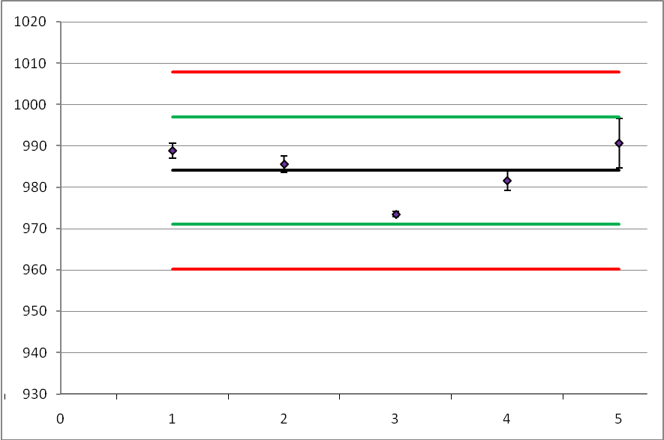

Fig 3 – Tech 2

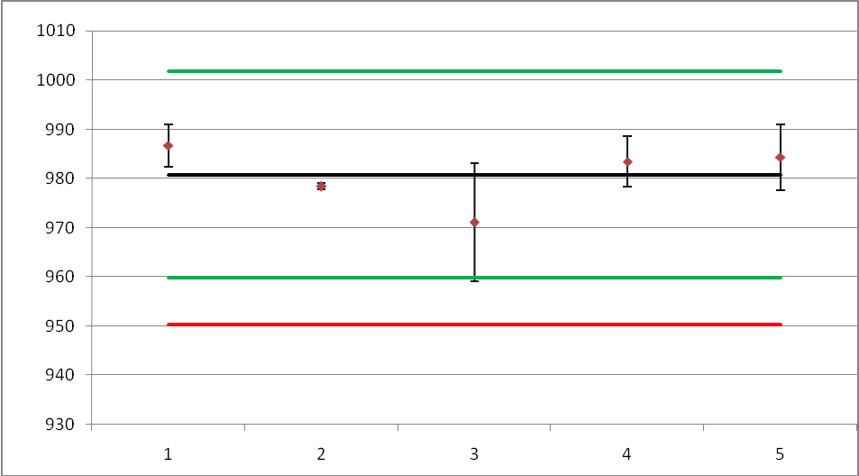

Fig 4 – 25WG1

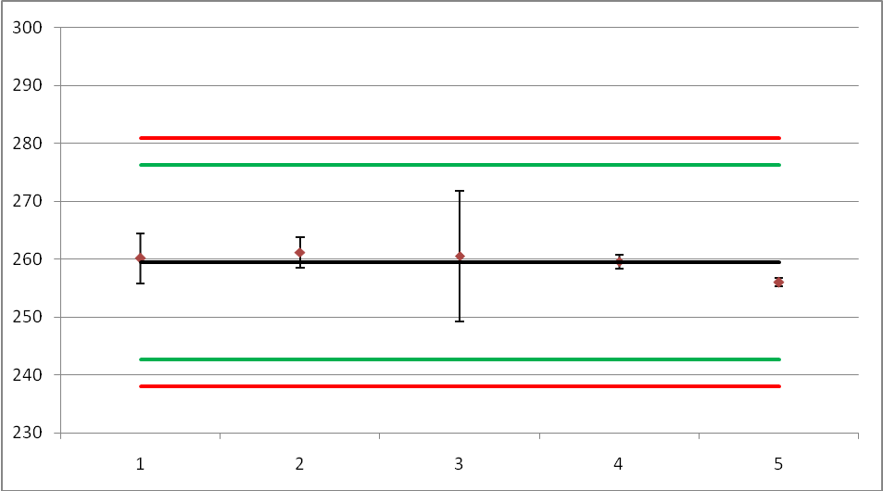

Fig 5 – 25WG2

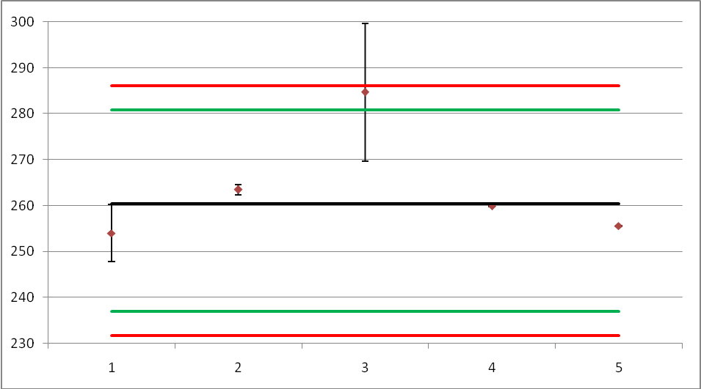

Fig 6 – 25WG3

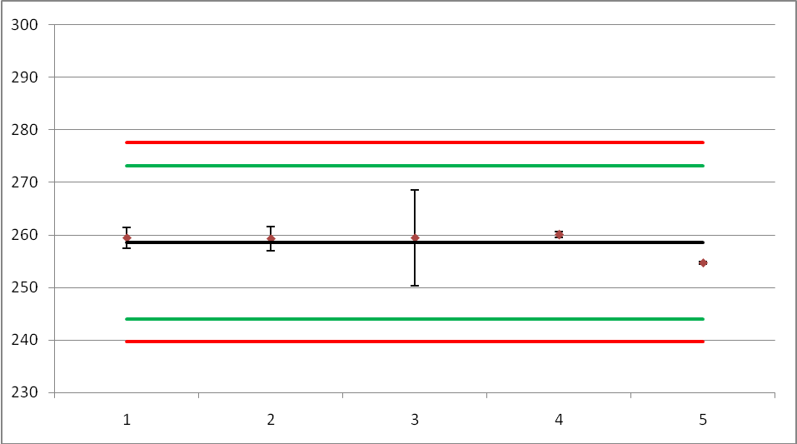

7. Conclusion

Five laboratories received samples for this collaborative trial and all of these laboratories submitted results. After the initial evaluation the calculated Reproducibility Standard Deviation (RSD_{R}) meets the Horowitz criteria for both Technical materials. The three WG samples did not meet the Horowitz criteria. On removsl of the data from laboratory 3 and recalculation of the statistics all WG samples meet the Horowitz criteria.

On the basis of these results ESPAC recommends that this method proceed to a full scale trial.

Acknowledgement:

ESPAC would like to express our gratitude to Frederic Joris and Laura Drukteinyte and their colleagues at ISK for supplying and distributing the samples and standards used in this Collaborative study.

